If you are given: The slope and y-intercept If you are given: A Graph

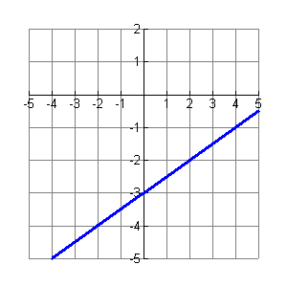

Ex:

Ex:

Slope = ½ and

y-intercept = -3

If you are given: The slope and a point If you are given: Two points

Ex:

Point (-2, -4)

Point (2, -2)

Ex:

Slope = ½ and

point (4,-1)

**How to Write the**

**Equation of a Line**

If you are given: If you are given:

# The slope and y-intercept A Graph

Fold here

Fold here

If you are given: If you are given:

The slope a Point Two points